|  |  |
| --- | --- |
| GEN AI LEARNING  **Complete Generative AI Learning – New Year Challenge** | WRITTEN BY: ALOY |

***Day – 12***

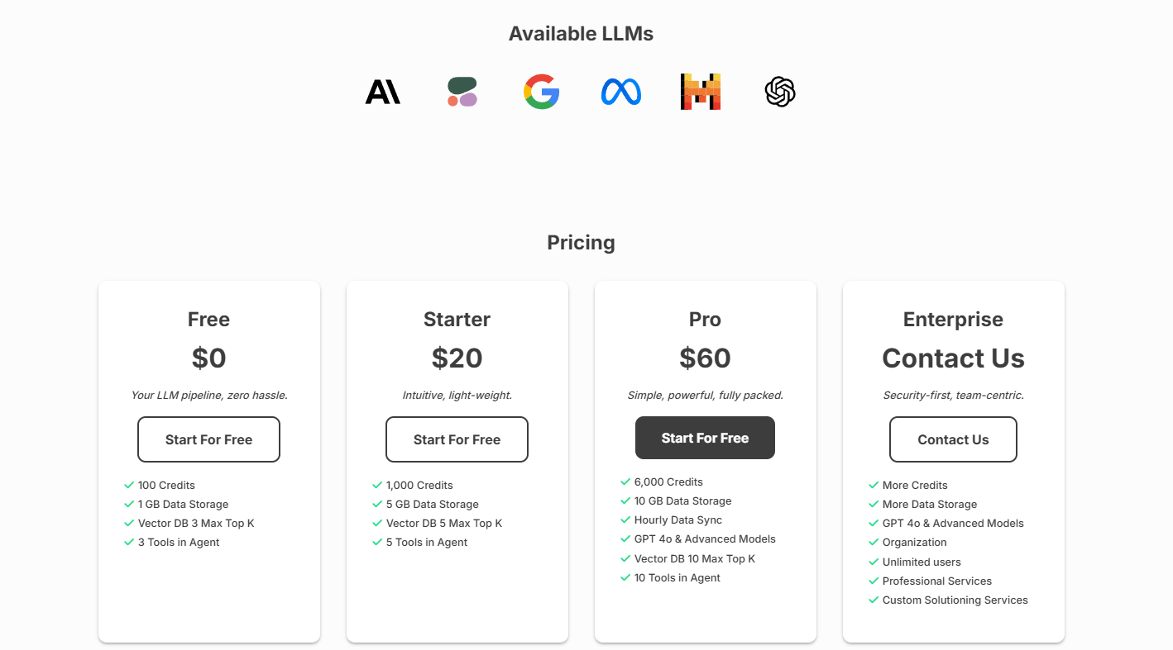

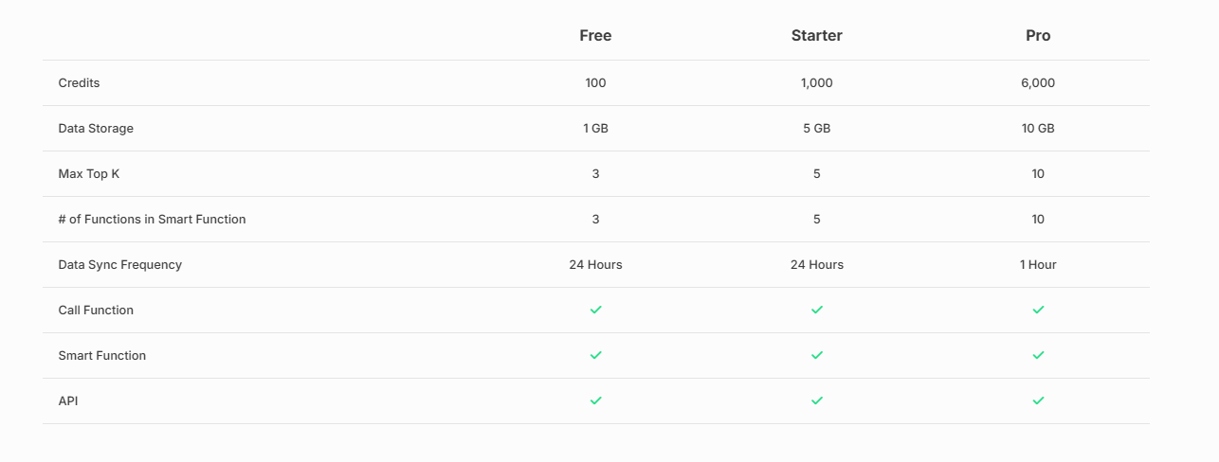

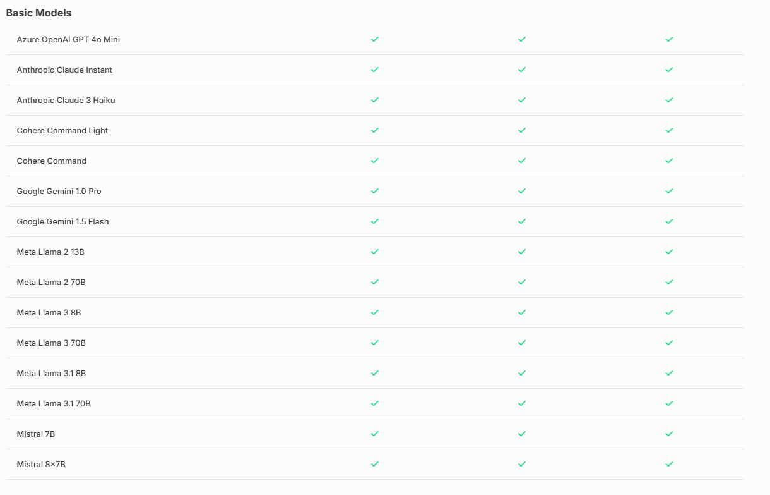

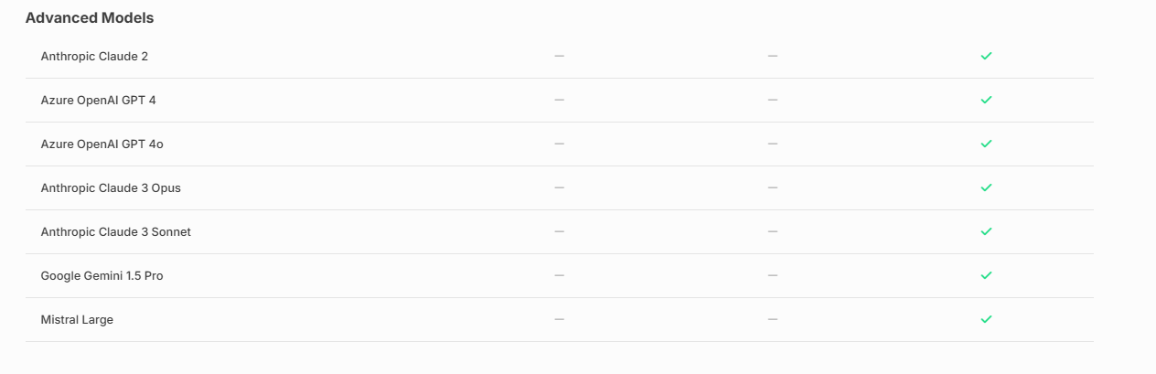

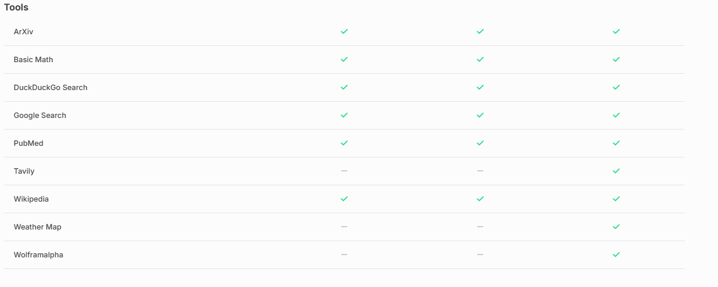

**Vext Flow: Low-Code LLM Workflow Builder**

**Create, Customize, and Deploy Your LLM Pipeline Within Minutes**

Skip the deep dive into open-source research and the struggle with tricky setups. With Vext Flow, you get a simple, guided system for assembling your LLM pipeline without the headache.

Build anything you need, from RAG powered by vector storage to combining different LLMs to adding internet searches into your pipeline.

**Code or Codeless, Your Choice**

This platform provides robust endpoints and APIs for those who prefer hands-on control, allowing you to create advanced, custom solutions.

Alternatively, if you'd rather stay code-free, the interface empowers you to harness the power of AI equally to your fellow developers without requiring you to write a single line of code.

Steps of creating flow for a simple QnA:

1. Login to the <https://vextapp.com/>
2. After login, click on dashboard or come to <https://app.vextapp.com/dashboard>
3. Click on “START” to create new project

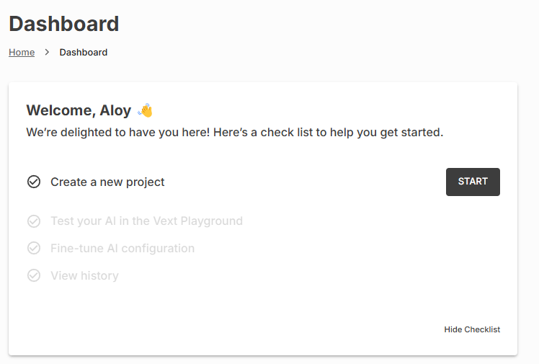

1. Type the name of the project

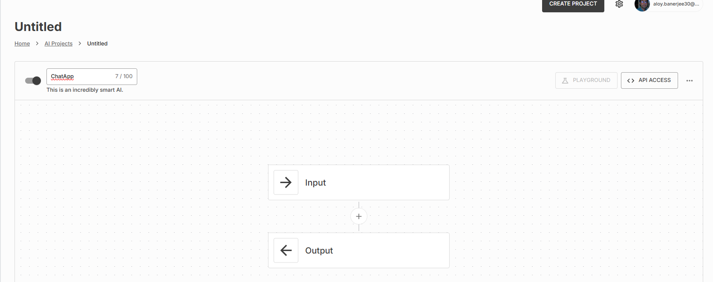

1. Create a data source to do QnA on your dataset. Give the dataset name and upload the necessary files after clicking on the “ADD SOURCE” button.

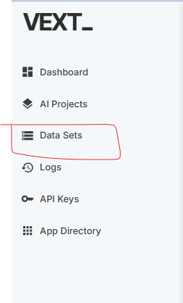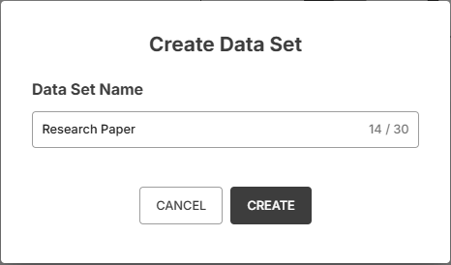

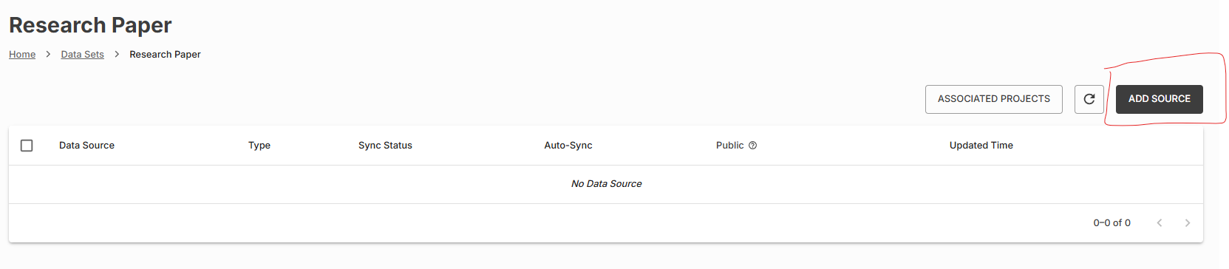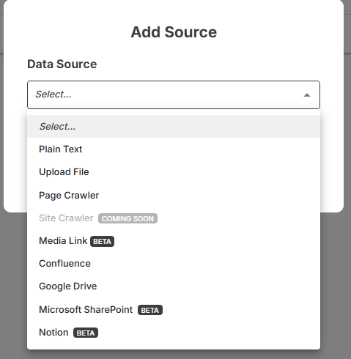

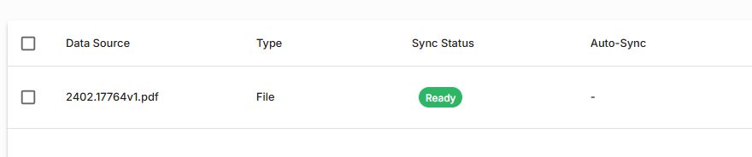

1. Once the uploaded file’s Sync Status is in Ready state we can start creating the flow.
2. You can choose the items between Input and Output. Options are many like below,

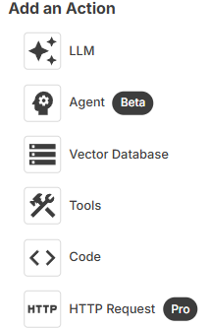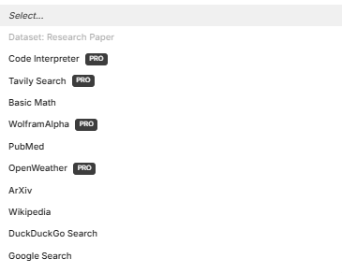

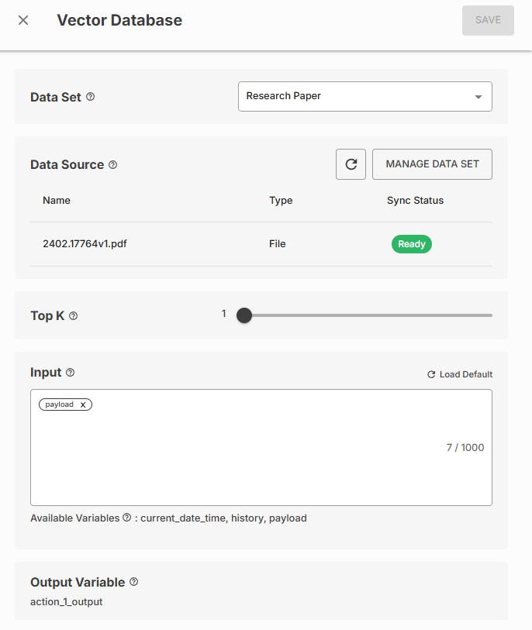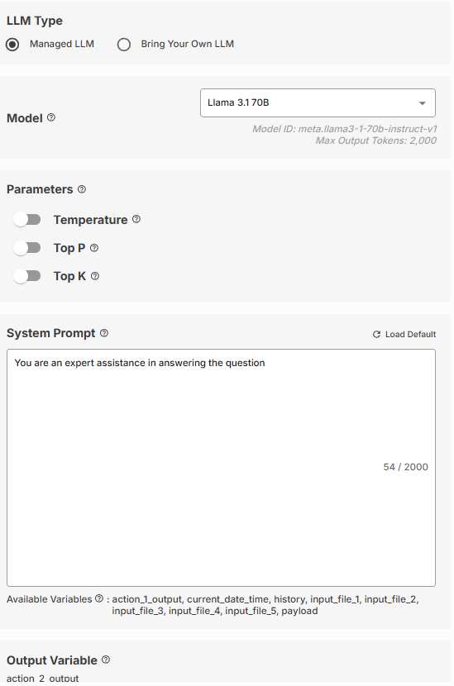

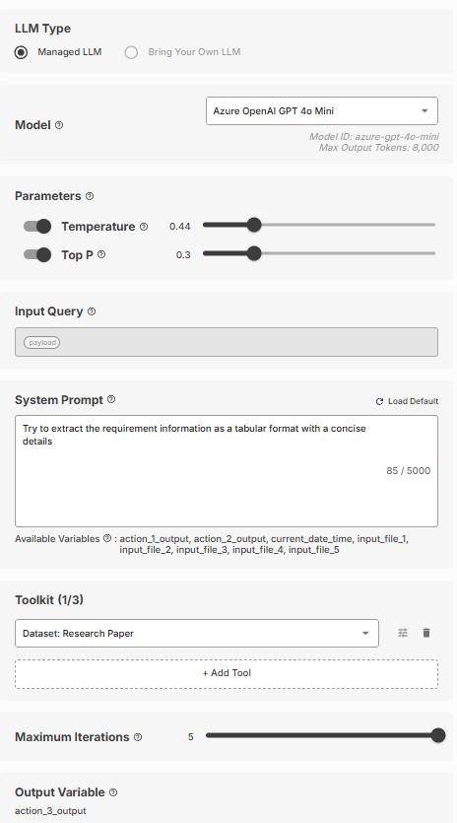

1. Below is the full workflow set up for QnA,

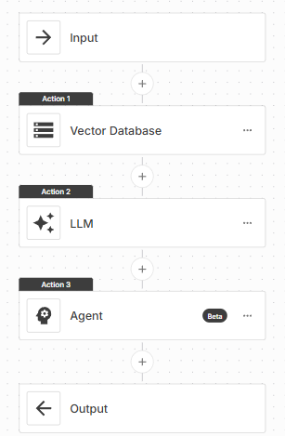

1. To test the workflow response, we can click the ‘PLAYGROUND’ and do the testing.

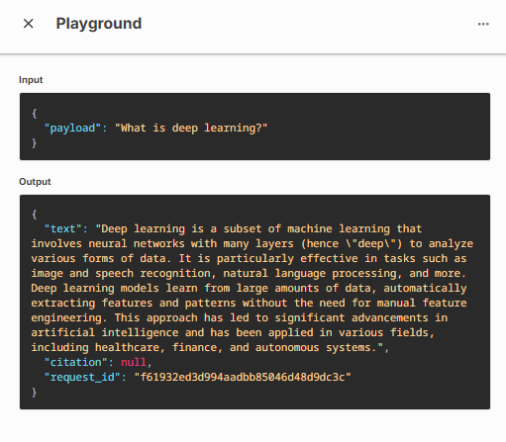

To access the workflow from code, one can, use the below code,

